TWO DAYS NATIONAL LEVEL
WORKSHOP
ON
USE OF STATISTICAL TECHNIQUES IN
EDUCATIONAL RESEARCH
March 04 & 05, 2012
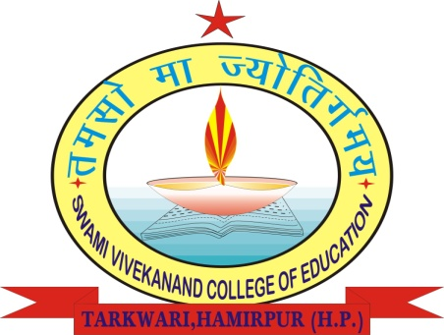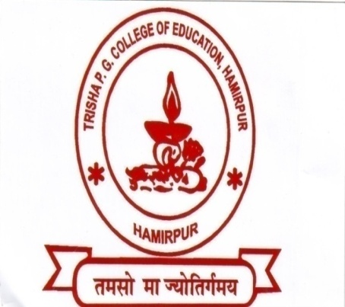

SWAMI VIVEKANANDA PG COLLEGE OF EDUCATION – TARKWARI
AND
TRISHA PG COLLEGE OF EDUCATION – THAIN (JOL SAPPAR)
DISTRICT HAMIRPUR - HIMACHAL PRADESH

PATRONS
* Dr. Vinod Kumar Sharma * Sh. N.K. Sharma * CA Rajeev Sharma
RESOURCE PERSON
Prof. Satish Chand Bhadwal
Deptt. of Education, H.P. University – Shimla.
DIRECTORS OF THE WORKSHOP
* Dr. Jaya Shree Samantaray 09418154044 * Dr. Raj Kumar 09816052663
COORDINATORS
- Dr. Rajesh Kumar 09418210517
- Dr. Lalit Mohan Sharma 08091465766
- Mrs. Neelam Kumari 09418921257
- Miss Nisha Chandel 09418641983
ABOUT THE WORKSHOP
This workshop is being jointly organized by Swami Vivekananda PG College of Education Tarkwari and Trisha PG College of Education , Thain (Jol Sapper) with the motive to orient, train and sensitize the Teacher Educators and Research Scholars to make judicious use of statistical techniques and methods in Educational Research as per the need and nature of the data collected. However, in view of the lack of research aptitude among teacher educators who are teaching M.Ed. course in various Colleges of Education, the workshop will prove fruitful to provide professional and technical assistance to needed population.
So in order to achieve the said motive both the institutions have joined their hands to organize the said workshop with the following objectives:-
- To make the research scholars aware of the best possible methods and procedures to carry out research work.
- To make appropriate use of data gathering tools for data collection.
- To make judicious use of statistical techniques in educational research.
PARTICIPATION
Respective Principals/Heads of the teacher education institutions are heartily invited as well as requested to participate and also depute at least two members from their teaching faculty and research scholars to make this workshop a success. The participants may confirm their participation latest by March 01, 2012 evening by contacting any of the coordinators telephonically or through E-mail/Fax at the following addresses:
E-mail ID’s: svntarkwari@yahoo.com & collegetrisha@yahoo.com
Tele/Fax: 01972265914 & 01972241833

REGISTRATION FEE
For Teacher Educators: Rs. 300/- per delegate.
For Research Scholars: Rs: 150/- per delegate.
For M.Ed. Students: No registration fee will be charged.

WORKSHOP SCHEDULE
DAY 01 – SUNDAY THE 4TH MARCH 2012
VENUE : TRISHA P.G. COLLEGE OF EDUCATION, THAIN (JOL SAPPER)
09:00 AM – 10:00 AM | Registrations
10:00 AM – 10:30 AM | Inaugural Session
10:30 AM - 11:30 AM | Technical Session -I
11:30 AM - 11:40 AM | Tea Break
11:40 AM – 01:0-00 PM | Technical Session –II
01:00 PM – 01:30 PM | Lunch Break
01:30 PM – 03:00 PM | Technical Session –III
03:00 PM – 05:00 PM | Thematic Session

DAY 02 – MONDAY THE 5TH MARCH 2012
VENUE : SWAMI VIVEKANANDA P.G. COLLEGE OF EDUCATION, TARKWARI
10:00 AM – 11:30 AM | Technical Session –IV
10:30 AM – 11:40 AM | Tea Break
10:40 AM - 01:00 AM | Technical Session -V
01:00 PM – 01:30 PM | Lunch Break
01:30 PM – 03:00 PM | Discussion
03:00 PM – 04:30 PM | Valedictory Function

ON
USE OF STATISTICAL TECHNIQUES IN EDUCATIONAL RESEARCH
MARCH 04TH & 05TH, 2012
REGISTRATION FORM
Name (Dr./Ms./Mr.):___________________________________________________________________
Designation:_________________________________________________________________________
Educational Qualification:______________________________________________________________
Teaching Experience:__________________________________________________________________
Corresponding Address:________________________________________________________________
___________________________________________________________________________________
___________________________________________________ Pin Code ________________________
Contact No.:___________________ E-mail:________________________________________________
Fee Details (Tick whichever is applicable): Cash ⁮ Draft ⁮ Amount: ________________
Draft No.: __________________ Bank _____________________ Dated:_________________________

Date: ________________________
Place: ________________________ Signature
_________________________
------------------------------------------------------------------------------------------------------------------------------------
Mail to Either
The Principal, The Principal,
Trisha PG College of Education, Swami Vivekanad PG College of Education,
Thain,P.O.,Jol Sappar, Tarkwari,P.O.,Dungrin,Tehsil Bhoranj,
Distt. Hamirpur (H.P.) Distt. Hamirpur (H.P.)-176045.

ON
USE OF STATISTICAL TECHNIQUES IN EDUCATIONAL RESEARCH
MARCH 04TH & 05TH, 2012

FEEDBACK
Name (Dr./Ms./Mr.):_________________________________________________________________________________________________
Designation:__________________________________________________Educational Qualification:_________________________________
Teaching Experience:_______________________________ Correspondence Address:_____________________________________________
_________________________________________________________________________________________________________________
___________________________________________________ Contact No.:___________________ E-mail:_________________________
Strengths of Workshop:_____________________________________________________________________________________________
________________________________________________________________________________________________________________
Weaknesses of Workshop:____________________________________________________________________________________________
________________________________________________________________________________________________________________
________________________________________________________________________________________________________________
Suggestions:______________________________________________________________________________________________________
________________________________________________________________________________________________________________
________________________________________________________________________________________________________________

(Signature)

The Governing Body, Principal, Staff & Students of
Swami Vivekananda PG College of Education - Trakwari
And
Trisha PG College of Education - Thain, (Hamirpur)
Cordially seek your benign presence on the occasion of
Valedictory Function
Of
Two Days National Level Workshop on
“Use of Statistical Techniques in Educational Research”
Being held on March 05, 2012 at 03:00 PM
In
Seminar Hall, Swami Vivekananda PG College of Education, Tarkwari
Prof. J.K. Chauhan
(Chairman, H.P. Subordinate Services Selection Board, Hamirpur)
Has very Kindly Consented to be the Chief Guest.

